**Clock App**

Use the tabs at the top to navigate between each section.

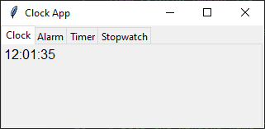

Alarm

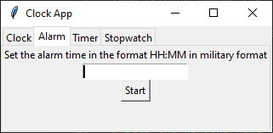

Enter the time you want the alarm to end in the entry field using military time format and press start. If you typed it in wrong, you will see this:

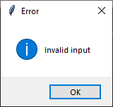

Otherwise, you will get this window when the alarm ends.

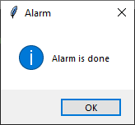

Timer

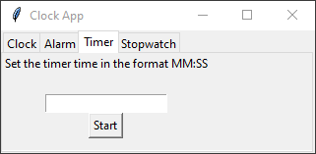

Enter how long you want the timer to go for in minutes and seconds and press start. If you type something wrong, you will get this window:



Otherwise, you will see the seconds remaining appear above the entry field.

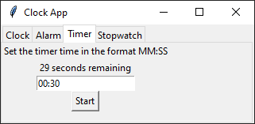

Once the timer is finished you will get this window:

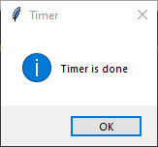

Stopwatch

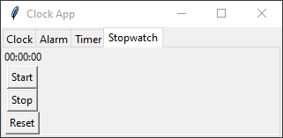

Press the start button to start the stopwatch. It will continue to count to count up every second until you press the stop button. Press the reset button to reset the stopwatch back to 0 seconds.